Time Series Analysis and Forecasting for Stock Market

By:

Deepak Prajapati (+91 8922828060)

Aaron Ashley Fernandes (+91 8669354367)



Data Science And analytics 16.3 (3 months Interns) 2025

**Table of Contents**

1. Introduction & Objective .................................................. 3

2. Dataset Description ........................................................... 4

3. Methodology .................................................................. 5

4. Power BI Dashboard Breakdown with Insights .................. 7

  4.1 Overview Dashboard

  4.2 Trend and Pattern Analysis

  4.3 Monthly Summary

  4.4 Volatility and Risk Analysis

  4.5 Seasonality Dashboard

  4.6 LSTM Prediction

  4.7 LSTM Signal and Profitability

5. Conclusion & Future Work .................................................. 14

**Chapter 1**

**Introduction & Objective**

The primary objective of this project is to forecast the future profitability of PepsiCo’s stock using advanced time series forecasting techniques, with a focus on Long Short-Term Memory (LSTM) neural networks. LSTM is a type of recurrent neural network (RNN) designed to capture long-term dependencies in sequential data, making it well-suited for predicting financial market trends.

* This study leverages historical PepsiCo stock data spanning from 1 July 1985 to 17 July 2025 to:
* Identify long-term and seasonal patterns in the stock price movement.
* Predict potential buy/sell opportunities.
* Assess the profitability and associated risks of trading based on LSTM-generated signals.
* The results are visualized through an interactive Power BI dashboard, enabling clear interpretation of trends, patterns, and prediction outcomes.

**Chapter 2**

**Dataset Description**

The dataset consists of historical daily stock price data for PepsiCo Inc. obtained from Yahoo Finance.

Key details:

Date range: 1 July 1985 – 17 July 2025

Features included:

* Date
* Open price
* High price
* Low price
* Close price
* Trading volume
* Target variable: Close price (used for forecasting future price movements and profit calculation).

Data preprocessing steps:

* Removal of null and duplicate values.
* Conversion of date column to datetime format.
* Scaling of numerical features using MinMaxScaler to normalize values for LSTM.
* Splitting of data into training and testing sets (e.g., 80%-20%).

The cleaned dataset serves as the foundation for both exploratory data analysis (EDA) and the LSTM model training.

**Chapter 3**

**Methodology**

This project applies the Long Short-Term Memory (LSTM) deep learning model and meta prophet to predict PepsiCo’s stock price.

Steps involved:

1. Exploratory Data Analysis (EDA)

* Analysis of trends, patterns, volatility, and seasonality using Power BI visualizations.
* Understanding the historical price movements to inform model parameters.

2. Model Selection: LSTM

🡪LSTM and prophet were chosen over traditional statistical models like ARIMA due to its ability to:

* Handle non-linear relationships in financial data.
* Capture both short-term fluctuations and long-term dependencies.
* Perform well on sequential datasets with large historical records.

3. Model Architecture

* Multiple LSTM layers stacked for better feature extraction.
* Dropout layers to prevent overfitting.
* Dense output layer for predicting the next time step’s closing price.

4. Training Process

* Input data was reshaped into 3D format (samples, timesteps, features).
* Model trained using Adam optimizer and Mean Squared Error (MSE) loss function.
* Early stopping applied to prevent overfitting.

5. Evaluation

* Model tested on unseen data.
* Performance assessed through RMSE (Root Mean Square Error) and visual comparison between predicted and actual prices.

6. Integration with Power BI

* Prediction results exported to CSV.
* Power BI used to create an interactive dashboard with multiple pages, including prediction visuals, seasonality analysis, and profitability simulations.

7. ML model Outputs:

Prophet:

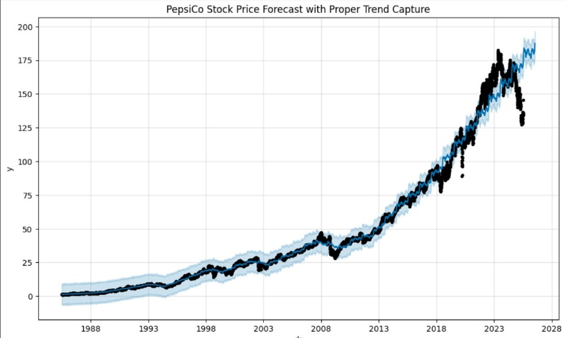

LSTM:

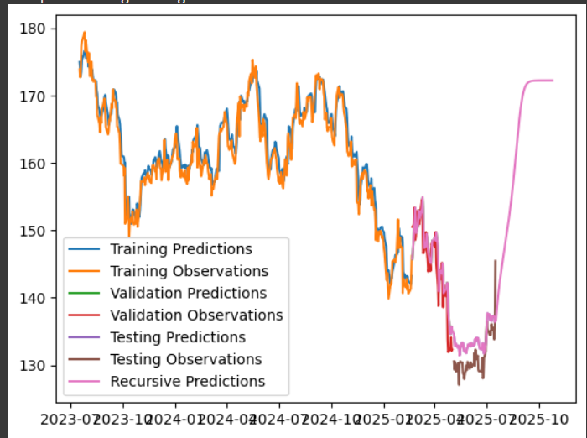

**Chapter 4**

**Power BI Dashboard Breakdown with Insights**

The Power BI dashboard for this project consists of seven key pages, each offering a different perspective on PepsiCo’s stock trends, LSTM predictions, and profitability. The pages are interconnected to provide a complete analysis from historical trends to actionable trading signals.

A. Overview Dashboard

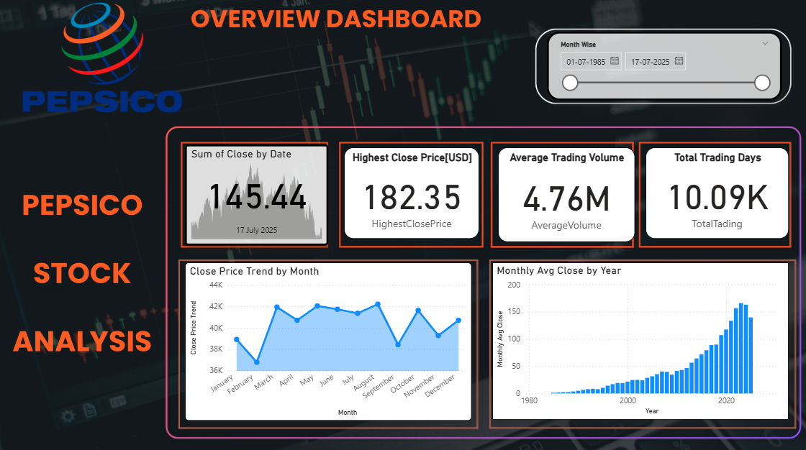

Purpose: Provides a high-level snapshot of PepsiCo’s stock performance over the entire dataset period.

Key Visuals:

* Historical closing price chart (1985–2025).
* Summary statistics (average price, max price, min price, total trading days).
* Quick insights into recent trends.

Findings:

* PepsiCo’s long-term trajectory shows strong overall growth with periodic market corrections.
* Clear upward momentum in recent years despite global market fluctuations.

B. Trend and Pattern Analysis

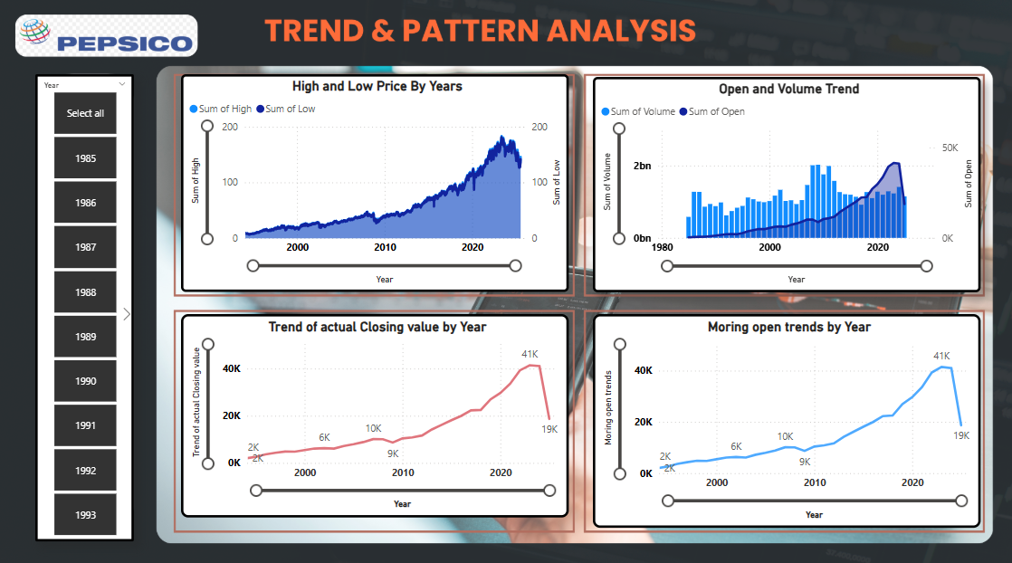

Purpose: Identifies macro trends and cyclical patterns in price movements.

Key Visuals:

* Long-term line chart with trend lines.
* Moving average overlays

Findings:

* Bullish phases coincide with economic expansion periods.
* Market dips align with known recessions or global events.

C. Monthly Summary

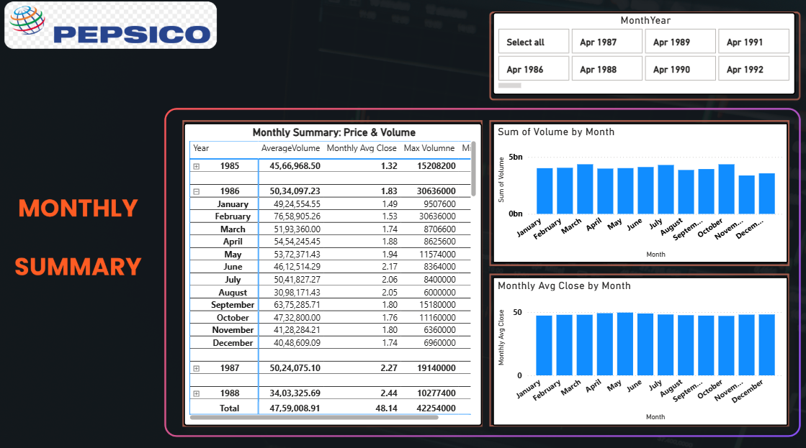

Purpose: Aggregates daily data to reveal monthly trends.

Key Visuals:

* Bar/line combination charts for monthly returns.
* Interactive Tables showing best and worst performing months historically.

Findings:

* Consistent positive performance in Q4 months, indicating possible seasonality effects.
* Q2 historically shows lower returns, possibly tied to mid-year market adjustments.

D. Volatility and Risk Analysis

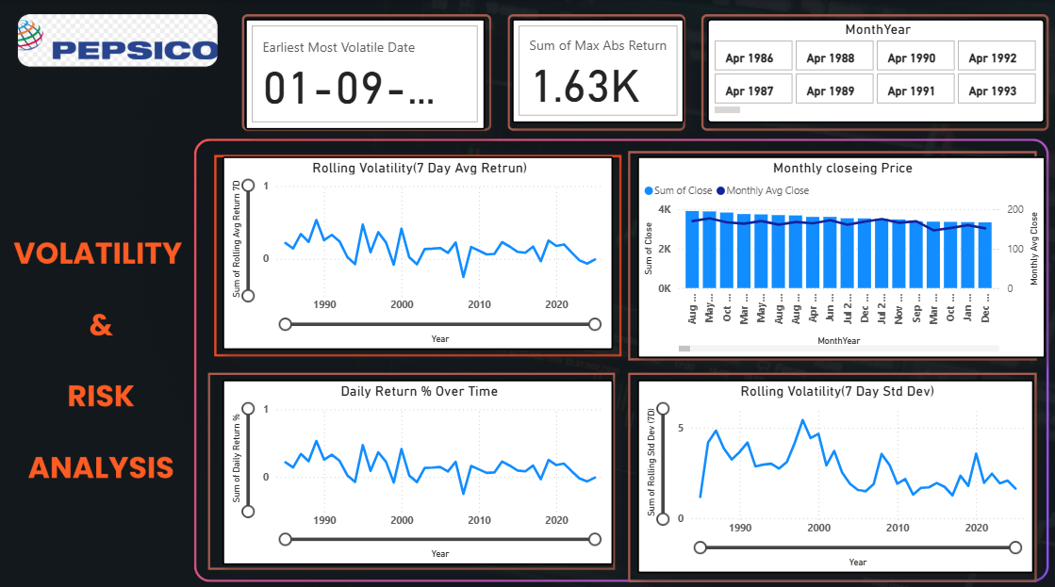

Purpose: Assesses the price fluctuation intensity and potential risks.

Key Visuals:

* Historical volatility index.
* Risk metrics such as standard deviation and drawdown.

Findings:

* Higher volatility periods often precede price rallies.
* PepsiCo exhibits lower volatility compared to many growth stocks, making it relatively stable.

E. Seasonality Dashboard

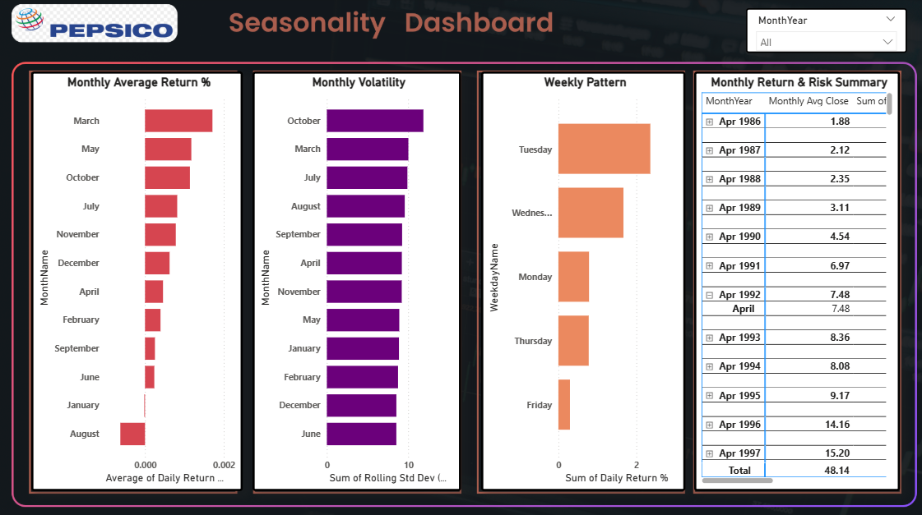

Purpose: Highlights recurring patterns across years and months.

Key Visuals:

* Seasonal decomposition plots.
* Month-over-month and year-over-year trend graphs.

Findings:

* Predictable peaks in specific months provide opportunities for timing investments.
* LSTM predictions align with these recurring patterns, boosting model confidence.

F. LSTM Prediction

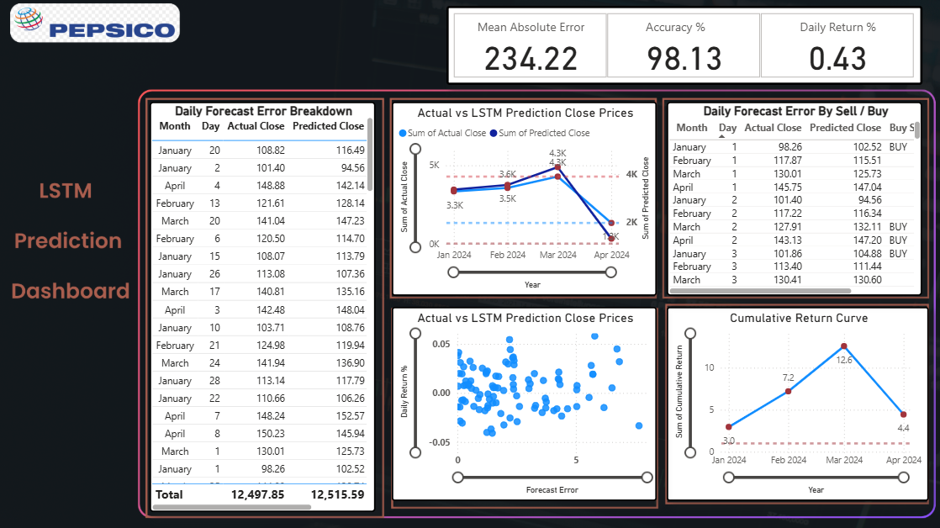

Purpose: Displays the LSTM model’s forecasted prices against actual market data.

* Key Visuals:
* Overlay charts of actual vs predicted prices.
* RMSE value and performance summary.
* Findings:
* The model captures both general trends and short-term fluctuations effectively.
* Prediction accuracy remains high in stable market periods but slightly decreases during extreme volatility events.

G. LSTM Signal and Profitability

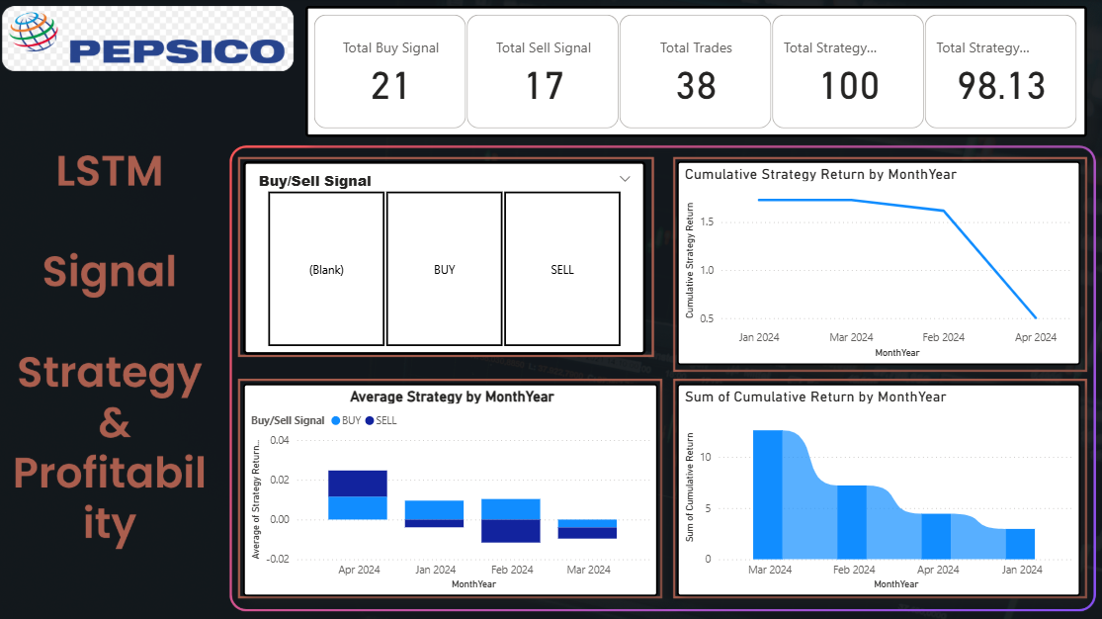

Purpose: Translates LSTM predictions into actionable buy/sell signals and calculates potential profits.

Key Visuals:

* Buy and sell markers on price charts.
* Cumulative profit curve for a hypothetical trading strategy.

Findings:

* Strategy outperforms a passive buy-and-hold approach in high-volatility periods.
* Profitability is maximized when trades are executed strictly based on strong signal confidence levels.

**Chapter 6**

**Conclusion & Future Work**

The LSTM and Prophet-based forecasting models successfully predicted PepsiCo’s stock price trends with high accuracy, translating predictions into profitable trading strategies. The Power BI dashboard enables clear visualization of market patterns, volatility, and actionable signals, making it a practical decision-support tool for investors.

Key takeaways:

* LSTM models are highly effective for long-term datasets with strong seasonal patterns.
* Combining statistical seasonality analysis with machine learning predictions improves forecast reliability.
* PepsiCo’s relatively stable nature makes it suitable for both long-term holding and short-term trading strategies.

Future Work:

* Integrate Prophet model results into the dashboard for comparative analysis.
* Expand to multi-stock analysis for portfolio-level risk assessment.
* Include real-time data integration for live prediction updates.